RULES OF CONDUCT IN THE EVENT OF
FIRE EMERGENCY
- REMAIN CALM, DO NOT PANIC
- FOLLOW THE INSTRUCTIONS SHOWN HERE FOR A QUICK AND ORDERLY EXIT
PREVENTIVE MEASURES
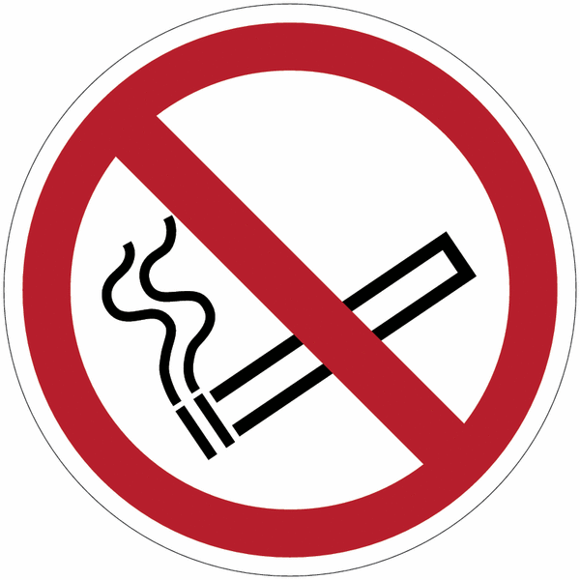
IT IS PROHIBITED TO
- SMOKE on the premises and in the courtyard of the Residence;
- tamper with and/or disable and/or remove fire-fighting systems;
- LEAVE THE FIRE DOORS OPEN, except for doors equipped with a self-closing system;
- use, on the premises, cookers or hot plates of any kind for heating food, stoves and heating or lighting appliances in general that are electrically operated with visible heating elements or powered by solid, liquid or gaseous fuels;
- keep deposits, even small ones, of flammable substances in rooms that are part of the volume intended for the activity;
- obstruct external and internal emergency exits and stairways, which must be left absolutely clear at all times;
- light candles inside the Residence;
- use unauthorised electrical appliances and power strips or extension cords.
IN CASE OF EMERGENCY
If you see a fire GIVE THE ALARM:
- call the 112 Emergency Number directly and notify the internal emergency number 02.6448.9100 as soon as possible.
WHAT TO COMMUNICATE
- name and surname, possibly your telephone number
- address of the Incident - University Residence U42, via Comasina, 42 Milan
- location of the incident (room, venue, etc.)
- type of emergency in course
- stage of the emergency
- persons involved N........ of which N....... injured
- presence of disabled people

- OR press the manual fire alarm button nearest to you and then call the internal emergency number 02.6448.9100 as soon as possible.
If the OPTIAL-ACOUSTIC FIRE ALARM is activated, implement what is indicated “in case of evacuation”
IN CASE OF EVACUATION
- leave the room you are in, using the escape routes (corridors, stairs, etc.) appropriately marked by green signs
- do not linger to retrieve personal belongings
- help, without endangering your safety, a person with reduced or impeded mobility/impaired or limited visibility to reach the calm space (external emergency staircase landing)
- warn, without endangering your safety, a person with impaired or limited hearing
- do not run along escape routes and stairways
- DO NOT use lifts

- do not stand in the immediate vicinity of exits in order not to hinder rescue operations
- once outside the building, quickly reach one of the “gathering points” located in the garden, where you must wait for instructions on what to do
- do not re-enter the building until further notice. Reoccupation of rooms can only be authorised by the Fire Brigade

Additional indications for persons with reduced or impaired motor skills
- go to one of the landings of the EXTERNAL emergency stairs: they are a safe calm space, where you can wait for the arrival of the Fire Brigade.
- if you are on the ground floor, exit the building and reach one of the gathering points

