Title

J.L. First¹, P.L. Second² and J.C. Third²

¹Department of Aerosols, University of Somewhere, City, Postcode, Country
²Department of , National Research Centre, City, Postcode, Country
Keywords: first, second, third, fourth, fifth.
Associated conference sessions: 1, 2, 3, 4, 5, 6
Presenting author email

Please use this template for abstract preparation and submit your abstract in .pdf format.
The abstract should be in double column (like this example) and ONE page long (any additional page will be automatically deleted). Use A4 page set-up and make all margins (top, bottom, left, right) 20 mm wide. Use 10 pt Calibri font (except for the title which should be in 12 pt bold and in sentence case). Centre the title, the authors’ names, the addresses, keywords, conference topics and contact email address. Please compose a title that clearly and succinctly describes the content of your work, in order to maximise its impact.
Start each paragraph, except the first, with an indent. Justify the body of the text both left and right. Do not use page numbers. Keywords and listing of associated topics are there to draw attention to your abstract, and to help the organisers allocate the abstract to the most appropriate reviewers and conference session.
Use clear English to write your abstract, with an emphasis on describing what is new and why it should attract the attention of the audience.
Figures can be in colour or in black and white. Ensure that Figures and Tables have a caption and that they are numbered consecutively.

Table 1. Comparison between theoretical predictions and experimental measurements.
Month | Measured density (μg/m3) | Predicted density (μg/m3)
Feb | 0.4 | 0.4711
Jun | 2.4 | 1.528×10⁴

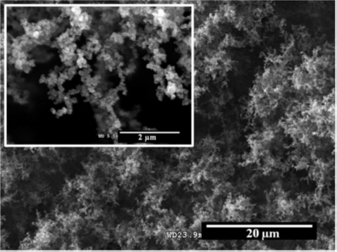
Figure 1. Upper view SEM micrograph of a dry ES deposit formed by carbon nanoparticles.

- References in the text should be made in the style (Rosner, 2000), Fernandez de la Mora and Kozlowski (2013) or as Neubauer et al (2010). Examples of references are shown below.
Leave a blank line above the list of references, and above the acknowledgements. A read ¶ indicates the line that must be kept during abstract preparation
Section headings, equations etc can be used but within the space limits and the formatting requirements listed above.

This work was supported by (insert here your acknowledgments and funding information).

References
Fernandez de la Mora, J. and Kozlowski, J. (2013) J. Aerosol Sci. 57, 45-53.
Neubauer, N., Seipenbusch, M. and Kasper, G. (2010) Proc. European Aerosol Conference, EAC2010, Granada.
Rosner, D.E. (2000) Transport Processes in Chemically Reacting Flow Systems. Dover Publications.

